**Project synopsis**

**Project title:**

Online Student Registration System

**Introduction and objectives of the project:**

Student Online admission is a vital part one of any university’s running because students are what keep a University alive. The Student admission is one of the most important activities within a university as one cannot survive without student. A poor admission system can mean fewer students being admitted into a university because of mistakes or an overly slow response time

Currently the student submits hardcopy of filled application form to the college and office staff enters all data into excel file and write same in manual register. College staff checks all the application and calculates marks list for selection process. After the manual work the college staff sends letter to selected candidates or they post in the notice board. The student has to come to the college to check the selected candidate’s lists in the notice board.

Proposed Online Student Registration System will eliminate all the manual intervention and increase the speed of whole process. This Web portal will help the student to get the information about a particular course and then they can easily register them self in a particular course. After successful submission, system will give unique registration no for each student. Student can login into system by using registration id and they can check shortlisted candidate details. The management of the college can easily see the records of the students, their registered course and fees. College staff can short list the candidates instantly without any errors.

Through this online system we overcome many Problems.

* Time and Money is saved.
* Nothing is done manually.
* Long lines in the department for these issues.

**Project category:**

RDBMS (Relational Database Management System)

**Project platform:**

**Front End:** PHP

**Back End:** MySQL Server

**PHP:**PHP is a server-side scripting language designed for web development but also used as a general-purpose programming language. PHP is a recursive acronym for "PHP: Hypertext Preprocessor". PHP is a server side scripting language that is embedded in HTML. It is used to manage dynamic content, databases, session tracking, even build entire e-commerce sites. It is integrated with a number of popular databases, including MySQL, PostgreSQL, Oracle, Sybase, Informix, and Microsoft SQL Server. The PHP code is written in the <?php and ?>.

**MySQL:   
MySql**is a powerful database. It's very good and free of charge. Many developers in the world selected mysql and php for developing their website.  MySQL uses a standard form of the well-known SQL data language. MySQL works very quickly and works well even with large data sets.

**Hardware requirement specification:**

**Operating System:** Windows XP / Windows 7/ Windows 8

**Hard disk:** Minimum 40 GB

**RAM:** Minimum 512 MB

**Processor –** Minimum Pentium Dual Xenon Processor

Keyboard and Mouse

**Software requirement specification:**

XAMPP Software v 3.2.1

Apache server 1.8.2

MySQL database Server 5.5

**IDE**: VS Code 1.53

**DFD(Data flow Diagram):**

**Level 0:**

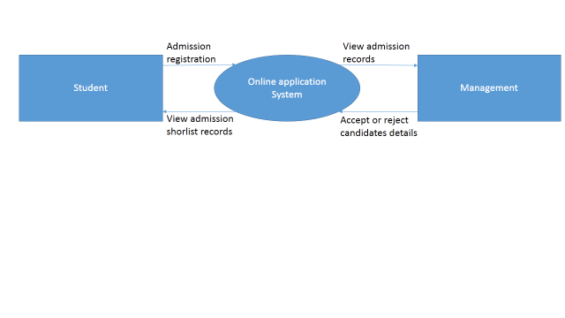

**Level 1:**

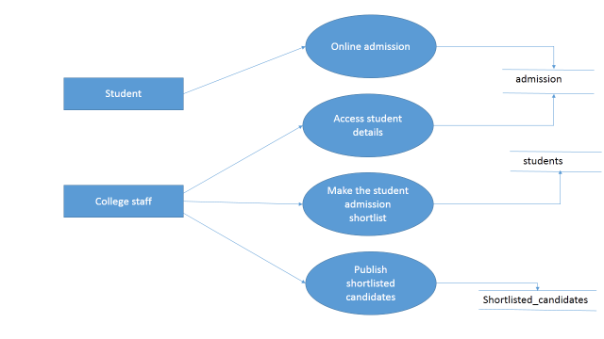

**ER Diagram:**

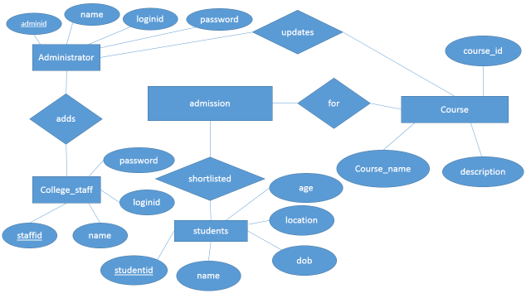

**Testing Technologies and Security mechanisms:**

Different testing levels

* Unit testing
* Integrated testing
* Validation testing
* Output testing
* User acceptance testing

1. **Unit testing:**

Unit testing focuses on verification effort on the smallest unit of software design module. Using the unit test plans. Prepared in the design phase of the system as a guide important control paths are tested to uncover errors within the boundary of the modules. The interfaces of each of the modules under consideration are also tested. Boundary conditions were checked.

All independent paths were exercised to ensure that all statements in the module executed at least once and all error-handling paths were tested. Each unit was thoroughly tested to check if it might fall in any possible situation. This testing was carried out during the programming itself. At the end of this testing phase each unit was found to be working satisfactorily as regarded to the expected out tom the module.

1. **Integration Testing**:

Data can be across an interface one module can have an adverse effect on another's Sub function when combined may not produce the desired major function; global data structures can present problems. Integration testing is a symmetric technique for constructing tests to uncover errors associated with the interface. All modules are combined in this testing step. Then the entire program was tested as a whole.

1. **Validation Testing:**

At the culmination of integration testing software is completely assemble. As a package. Interfacing errors have been uncovered and corrected and find; series of software test-validation testing begins. Validation testing can be defined in many ways but a Simple definition is that validation succeeds when software functions in manner that is reasonably expected by the consumer.

Software validation is achieved through a series of black box tests that demonstrate conformity with requirement after validation test has been conducted one of two conditions exists.

* The function or performance Characteristics confirm to specification that are accepted.
* A validation from specification is uncovered and a deficiency created.

Deviation or errors discovered at this step in this project is corrected prior to completion of the project with the help of user by negotiating to establish a method for resolving deficiencies. Thus the proposed system under consideration has been tested by using validation testing and found to be working satisfactorily.

1. **Output testing:**

After performing the validation testing the next step is output testing of the proposed system since a system is useful if it does not produce the required output in the specific format required by them tests the output generator displayed on the system under consideration. Here the output is considered in two ways - one is onscreen and the other is printed format. The output formation the screen is found to be correct as the format was designed in the system design phase according to the user needs. As far as hardcopies are considered it goes in terms with the user requirement Hence output testing does not result any correction in the system.

1. **User acceptance Testing:**

User acceptance of the system is a key factor for success of any system. The system under consideration is tested for user acceptance by constantly keeping in touch with prospective System and user at the time of developing and making changes whenever required.

**Project modules:**

**Admission module:** This module is for new students where student can register their admission details by entering their profile information, qualification details, etc.

**Data entry module:** This module is for college staff to enter student admission records manually. All record stores in admission module. Here college staff can process the admission form according to student marks.

**Status view module:** Here management or administrator can accept or reject student admission record. If it is rejected then it provides option to enter reason for rejection. The system also keeps track of statistical reports of daily activities of the Student Registration Process.

**Selecting process:** Here college staff can shortlist the selected candidates. The administrator can able to send the admission offer letters for the short listed candidates.

**Admission process:** Here management has rights to accept or reject short listed student record after interview process.

**Report:** The system supports generation of reports based on different criteria.Here management can view applied student details, payment details, selected candidates, etc.

**Limitations:**

It cannot be used as offline since it is online program.  
Internet connection is required.  
Basic computer knowledge is required to work on the system.

**Future scope and further enhancement of the project:**

* In future we can make android mobile based application.
* In future we can add features like web cam based verification system, Certification verification, Interview process through online, Identity card after approval, etc.

**Conclusion:**

This website stores admission details submitted by students and college staff. This project will eliminate all the manual intervention and increase the speed of whole process. The system works in Apache server which executes PHP script and MySQL as backend for the database. The system is strong to handle daily operations where the database is cleared over certain time.

**Bibliography:**

Website: [www.w3schools.com](http://www.w3schools.com)

Website: [www.tutorialspoint.com/php](http://www.tutorialspoint.com/php)

Website: <http://www.tutorialspoint.com/mysql>

Book: Learning PHP MySQL JavaScript and CSS Book by Jason Gilmore